HLA-B*41 (101.542-06/06u) Lot No: 8R8 Expiry Date: 2027-05-01

Name:__________________

Sample ID:______________

DNA Conc.(ng/ul):_________

Test Date:_______________

Tested By:_______________

Review Date:_______________

Reviewed By:_______________

*Interpretation:___________ Failed lanes: ___________ Comments:_________________*

**Gel Picture**

|  |
| --- |
| PHOTO DOCUMENT |



Abbreviations

ICB Internal Control Band

AmpS: Amplicon Size

**Notes:**

Product sizes are approximate. For detailed information, see the lot-specific Specificity Table and Interpretation Table.

This table is intended as a guide. For interpretation always use the Interpretation Table and/or Specificity Table.

HLA-specific PCR products shorter than 125 base pairs have a lower intensity and are less sharp than longer PCR products.

Primer mixes 9 and 20 may have tendencies of unspecific amplifications.

Primer mix 24 contains a negative control, which will amplify the majority of HLA amplicons as well as the amplicons generated by the control primer pairs matching the human growth hormone gene. HLA-specific PCR product sizes range from 75 to 200 base pairs and the PCR product generated by the HGH positive control primer pair is 200 base pairs.



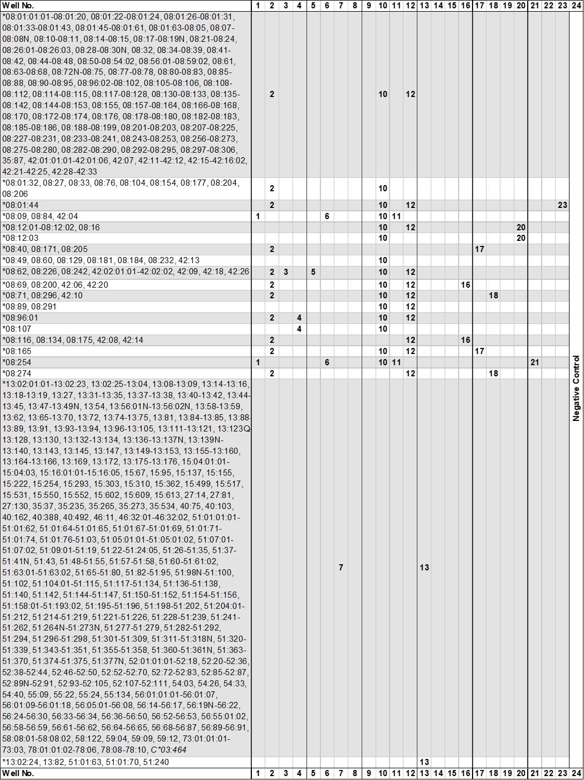









**1**HLA-B*41 alleles in bold lettering are listed as confirmed alleles on the on the IMGT/HLA web page [www.ebi.ac.uk/imgt/hla](http://www.ebi.ac.uk/imgt/hla), release 3.27.0, January 2017

**2**Alleles that have been deleted from or renamed in the official WHO HLA Nomenclature up to and including the last IMGT/HLA

database release can be retrieved from web page <http://hla.alleles.org/alleles/deleted.html>.

**3**The following HLA-B*41 primer mixes have two or more product sizes:

|  |  |  |  |
| --- | --- | --- | --- |
| Primer Mix | Size of spec. PCR product | Amplified HLA-B*41 alleles | Other amplified HLA Class I alleles |
| **2** | 165 bp  215 bp | *41:02:01:01-41:02:11, 41:04, 41:10-41:11, 41:13, 41:15, 41:18-41:19, 41:23, 41:27, 41:31, 41:36, 41:38-41:43, 41:45N-41:47, 41:49, 41:51-41:52, 41:55, 41:58, 41:62, 41:65, 41:68-41:69, 41:71-41:72, 41:74  *41:02:01:01-41:02:11, 41:04, 41:10-41:11, 41:13, 41:15, 41:18-41:19, 41:23-41:24, 41:27, 41:31, 41:36, 41:38-41:43, 41:45N-41:47, 41:49, 41:51-41:52, 41:55, 41:58, 41:65, 41:68-41:69, 41:71-41:72, 41:74 | *07:02:13, 07:02:35, 07:04:02, 07:05:10, 07:22:02, 07:68:02, 07:151:02, 07:209, 07:262:01, 07:424, 08:01:01:01-08:01:01:67, 08:01:03-08:01:27, 08:01:29-08:01:32, 08:01:34-08:05, 08:07-08:08N, 08:10-08:11, 08:13-08:15, 08:17-08:48, 08:50-08:53:01, 08:54:01-08:59:02, 08:61-08:78, 08:79:02-08:83, 08:85-08:88, 08:90-08:106, 08:108-08:128, 08:130-08:155, 08:157-08:180, 08:182-08:183, 08:185-08:212, 08:213:02-08:223, 08:225-08:231, 08:233-08:253, 08:256-08:290, 08:292-08:295, 08:297-08:306, 13:108, 14:05, 14:13, 14:53, 15:07:03, 15:383, 18:14, 35:05:01:01-35:05:06, 35:22:01:01-35:22:01:02, 35:51:01-35:51:02, 35:58, 35:66, 35:72, 35:87, 35:89, 35:97, 35:199, 35:232, 35:368, 35:389, 35:416, 35:427N, 35:440, 35:459N, 35:472, 35:481, 35:498-35:499, 35:509, 35:519, 35:541, 35:572, 37:09, 38:19, 39:03:01:01-39:03:02, 39:14:01:01-39:14:01:03, 39:24:01-39:24:03, 39:29, 39:37:01:01-39:37:01:02, 39:76, 39:120, 39:144, 39:152, 39:182, 39:184-39:185, 40:02:20, 40:35:03, 40:71, 42:01:01:01-42:01:01:03, 42:01:03-42:02:02, 42:05:01-42:12, 42:14-42:16:01, 42:17-42:33, 44:54, 44:106, 44:135, 44:158, 44:166, 44:184, 44:213, 48:12, 51:64, 51:148, 53:14, 53:67, 55:04, 55:49, 55:51, 55:86, 55:110, 58:18, **C*03:296:01, C*07:294, C*07:526:01, C*07:530:01, C*07:681**  *07:04:01-07:04:02, 07:19, 07:25, 07:146, 07:349, 08:01:01:01-08:05, 08:07-08:08N, 08:10-08:11, 08:14-08:15, 08:17-08:19N, 08:21-08:24, 08:26:01-08:39, 08:41-08:48, 08:50-08:54:02, 08:56:01-08:59:02, 08:61-08:69, 08:71-08:78, 08:80-08:83, 08:85-08:88, 08:90-08:106, 08:108-08:128, 08:130-08:142, 08:144-08:155, 08:157-08:170, 08:172-08:180, 08:182-08:183, 08:185-08:204, 08:206-08:231, 08:233-08:253, 08:256-08:280, 08:282-08:290, 08:292-08:306, 35:87, 37:09, 42:01:01:01-42:02:02, 42:05:01-42:12, 42:14-42:18, 42:20-42:33, 44:106, 44:158, 44:166, 44:213 |
| **3** | 75 bp  225 bp | *41:03:01, 41:10, 41:22  *41:45N | *07:143, 07:335, 08:62, 08:226, 08:242, 15:210, 15:426, 15:571, 18:01:01:01-18:01:12, 18:01:14-18:03:02, 18:05:01:01-18:15, 18:17N-18:24, 18:26-18:28, 18:30-18:42, 18:44:01-18:79, 18:81-18:97, 18:99-18:101, 18:103-18:106Q, 18:108-18:111, 18:113-18:119, 18:121-18:124, 18:126-18:226, 27:75, 35:162, 37:01:01:01-37:21, 37:23-37:40, 37:42N-37:54, 37:56-37:61, 37:63-37:84, 37:86N-37:94, 37:96-37:106, 39:31:01:01-39:31:01:02, 39:101, 39:128, 40:01:51, 40:149, 42:02:01:01-42:02:02, 42:09, 42:17-42:18, 42:26, 48:22, 48:30, 50:01:22, 50:77, 51:116, 51:354, **C*06:77, C*07:714, C*07:724**  *40:528 |
| **4** | 90 bp  265 bp | *41:12, 41:36  *41:04, 41:07 | *15:46, 15:106, 35:47, 35:154, 35:450, 40:10:01:01-40:10:02, 40:248, 40:282, 40:325, 40:351, 40:364, 40:526, 44:34:02, 44:245:01-44:245:02, 44:269, 49:48, 53:30, 56:67, 57:45, 58:111  *08:96:01, 08:107, 35:530, 53:15, 55:20 |
| **5** | 230 bp  255 bp | *41:23, 41:27  *41:05 | *07:143, 08:62, 08:226, 08:242, 18:03:01:01-18:03:02, 18:152, 18:171, 18:198, 18:203, 27:04:01-27:04:06, 27:06:01:01-27:06:02, 27:08, 27:11-27:12:01:03, 27:15, 27:20-27:21:02, 27:24-27:26, 27:31, 27:33, 27:36, 27:40, 27:61, 27:63, 27:66N, 27:68-27:69, 27:79, 27:86, 27:89w, 27:91, 27:100, 27:103, 27:105-27:109, 27:112-27:115, 27:120, 27:125, 27:138, 27:147, 27:149, 27:153-27:154, 27:165, 27:168, 27:173, 27:183, 27:192, 27:202, 27:204:01:01-27:204:01:02, 27:208, 27:210-27:211, 27:214, 27:222, 27:226, 27:229, 27:240, 27:242, 27:247, 37:37, 39:31:01:01-39:31:01:02, 39:101, 39:128, 40:43, 40:50:01:01-40:50:01:02, 40:166, 40:513, 42:02:01:01-42:02:02, 42:09, 42:17-42:18, 42:26-42:27, 45:06, 46:14w, 49:67, 50:52, 54:02, 55:16, 56:35, **C*03:278w, C*03:504w, C*07:714w, C*07:724w, C*16:86w**  *27:05:59 |
| **14** | 115 bp  180 bp  215 bp | *41:13  *41:49  *41:16 |  |
| **15** | 115 bp  255 bp | *41:29  *41:14 | *15:159, 15:260, 15:491, 35:302, 35:391, 35:437, 35:539, 40:79, 46:52 |
| **16** | 95 bp  290 bp | *41:18  *41:15, 41:62 | *07:115, 07:246, 07:327, 08:69, 08:200, 14:05, 35:440, 38:19, 39:03:01:01-39:03:02, 39:24:01-39:24:03, 39:37:01:01-39:37:01:02, 39:76, 39:120, 39:144, 39:152, 39:182,  39:184-39:185, 40:314, 42:06, 42:20, 48:07, **C*04:443, C*08:08:01-08:08:02**  *07:33:01, 07:53, 07:60, 07:100, 07:139:01, 07:442, 08:116, 08:134, 08:175, 13:71, 13:108, 14:05, 14:13, 14:53, 15:07:01:01-15:07:03, 15:45, 15:55, 15:68, 15:126, 15:197:02, 15:207, 15:324, 15:329, 15:331, 15:360, 15:383, 15:405, 15:421, 15:431, 15:450, 15:524, 18:14, 27:07:01-27:07:06, 27:11, 27:24, 27:32-27:34, 27:43, 27:138, 27:180, 27:219, 27:233, 27:251, 35:05:01:01-35:05:06, 35:22:01:01-35:22:01:02, 35:31, 35:51:01-35:51:02, 35:58, 35:72, 35:89, 35:97, 35:114, 35:199, 35:232, 35:368, 35:389, 35:416, 35:427N, 35:440, 35:459N, 35:472, 35:481, 35:498-35:499, 35:509, 35:519, 35:541, 35:572, 37:09, 38:19, 39:03:01:01-39:03:02, 39:14:01:01-39:14:01:03, 39:24:01-39:24:03, 39:29, 39:37:01:01-39:37:01:02, 39:76, 39:120, 39:144, 39:152, 39:182, 39:184-39:185, 40:02:01:01-40:03:02, 40:05:01:01-40:05:02, 40:08:01:01-40:09, 40:13, 40:18-40:19, 40:24, 40:27:01-40:27:03, 40:29, 40:35:01-40:35:03, 40:37, 40:39-40:40, 40:50:01:01-40:50:01:02, 40:56-40:58, 40:71, 40:78, 40:82, 40:85, 40:89-40:91, 40:94, 40:97, 40:104-40:105, 40:107, 40:111, 40:115, 40:119, 40:122, 40:133Q, 40:142N-40:145, 40:157, 40:164, 40:169, 40:173-40:174, 40:176, 40:180-40:181, 40:189, 40:200-40:203, 40:205-40:206, 40:209, 40:211, 40:214, 40:219-40:220, 40:224, 40:226, 40:229, 40:232, 40:246, 40:248, 40:254-40:255, 40:266-40:267, 40:271, 40:274, 40:276, 40:283-40:284, 40:287, 40:289-40:293, 40:296-40:297, 40:302-40:305, 40:309, 40:314, 40:320, 40:322, 40:331, 40:334:01-40:335, 40:337N, 40:345N, 40:347, 40:356, 40:359, 40:369, 40:371, 40:375, 40:378, 40:384, 40:390, 40:399N, 40:405, 40:409-40:410, 40:412-40:415, 40:420, 40:432, 40:435, 40:437-40:438N, 40:440-40:442, 40:444, 40:455, 40:457, 40:465, 40:467, 40:470, 40:481N, 40:489, 40:493, 40:496, 40:500, 40:504-40:505, 40:511N, 40:514N-40:515, 40:518, 40:521-40:522, 40:527, 42:08, 42:14, 44:54, 44:106, 44:135, 44:158, 44:184, 44:213, 46:12, 48:04:01:01-48:04:02, 48:13, 48:24, 48:51, 51:64, 51:81, 51:148, 53:14, 53:67, 55:04, 55:49, 55:51, 55:86, 55:110, 58:18, 58:27, **C*02:60, C*03:05:01:01-03:05:01:03, C*03:25, C*03:27, C*03:167, C*03:296:01-03:296:02, C*03:335, C*03:386, C*03:407, C*03:482, C*03:494, C*03:555, C*04:443, C*06:264, C*08:08:01-08:08:02** |
| **17** | 85 bp  245 bp | *41:19  *41:49 | *07:388, 08:40, 08:165, 08:171, 08:205, 27:83 |
| **19** | 130 bp  155 bp | *41:28  *41:11 | *44:80  *13:30, 40:293, 40:503, 44:219 |

**4**The following HLA-B*41 alleles can be distinguished by the different sizes of the HLA-specific PCR product:

|  |  |
| --- | --- |
| **Alleles** | **Primer mix** |
| B*41:04, 41:36 | 4 |
| B*41:10, 41:45N | 3 |

**5**The following alleles give rise to identical amplification patterns with the HLA-B*41 high resolution kit. These alleles can be distinguished by the HLA-B low resolution and/or the respective kits.

|  |
| --- |
| **Alleles** |
| B*41:08, B*40:136, 40:231, 40:279 |
| B*41:23, B*42:27 |
| B*41:46-41:47, B*44:166 |
| B*41:62, B*40:02:20 |

Abbreviations

w: might be weakly amplified.

?: nucleotide sequence information not available for the primer matching sequence.